Supplementary Figures

Figure S4. Structural identifiability analysis of the 28-ODE QSP model.
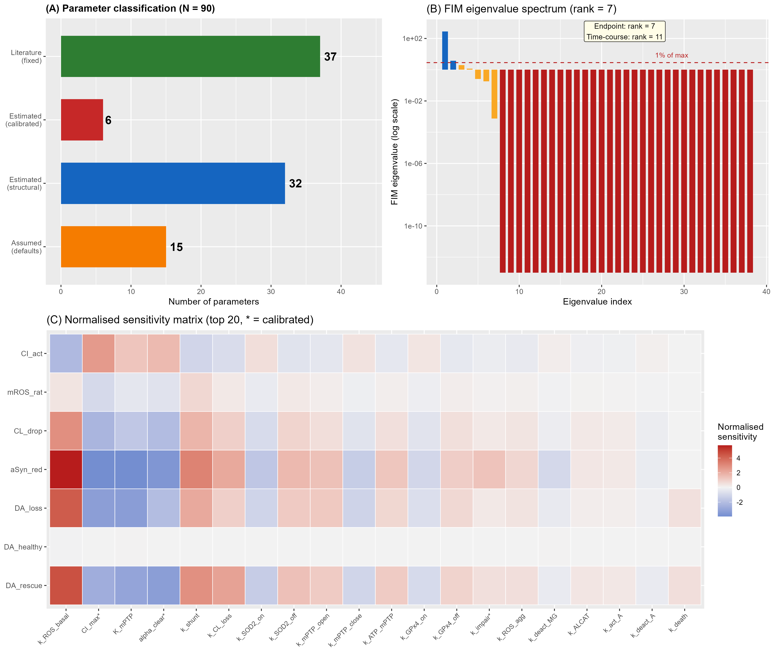
(A) Parameter classification by source type across the 90-parameter model: 37 literature-derived (independently constrained by published data), 32 estimated (fixed at values chosen to satisfy quantitative targets, not part of the formal calibration sweep), 6 calibrated (fitted via the four-stage calibration procedure), and 15 assumed (with mechanistic justification). (B) Fisher Information Matrix eigenvalue spectrum. The FIM achieves rank 7, equal to the number of calibration outputs, confirming that the experimental design extracts the maximum information content from the available data. The leading eigenvalue captures 97.5% of the total information. Time-course FIM analysis extends the identifiable subspace to 11 directions, indicating that longitudinal measurements would increase parameter resolution by roughly 1.6-fold. (C) Normalised sensitivity heatmap showing the top 20 parameters ranked by maximum absolute sensitivity across the 7 calibration outputs. Disease modifiers (CI_max, α_clear) and ROS pathway parameters contribute the largest sensitivity coefficients, consistent with the Sobol analysis (Figure S1).

Figure S5. Practical identifiability: profile likelihood analysis of the six calibrated parameters.
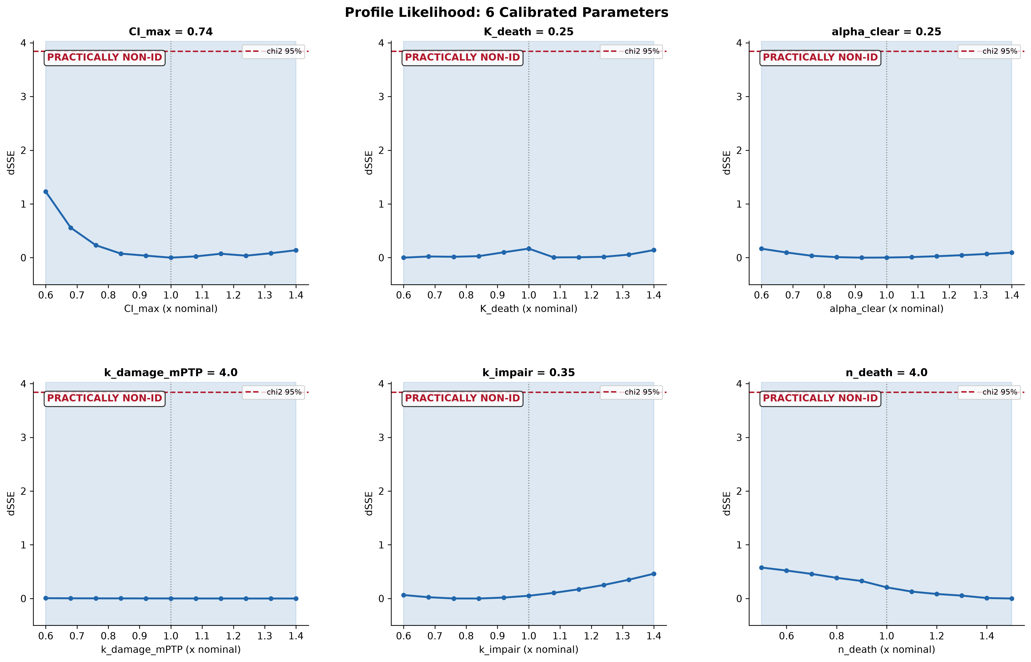
Profile likelihood curves for the six calibrated parameters (CI_max, α_clear, k_impair, K_death, k_damage_mPTP, n_death). Each panel shows the change in sum of squared errors (ΔSSE) as the focal parameter is fixed at values across its plausible range while all remaining calibrated parameters are re-optimised. The relatively flat profiles reflect the tightly coupled feedback architecture of the αSyn–CL–CI–ROS vicious cycle, in which compensatory parameter adjustments can maintain similar model outputs across a range of individual parameter values. This parameter compensation is a known property of biological feedback systems and does not compromise prediction accuracy when the model is used within its validated operating range. Dashed red lines indicate the χ² threshold for 95% confidence; vertical blue dashed lines mark nominal values.

Figure S6. Collinearity diagnostics and sensitivity correlation structure.
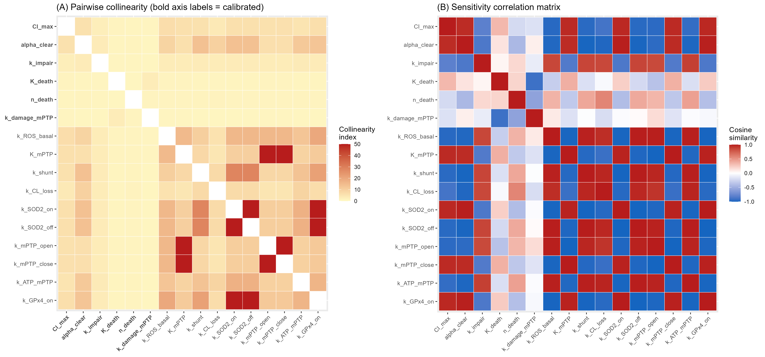
(A) Pairwise collinearity index heatmap for the six calibrated parameters and the top twelve sensitivity-ranked parameters. Higher collinearity indices (capped at 50 for visualisation) indicate parameter pairs whose effects on model outputs are difficult to distinguish independently. The highest collinearity occurs between parameters that share the same regulatory switch (k_SOD2_on and k_SOD2_off, the SOD2 antioxidant activation/deactivation pair; k_mPTP_open and k_mPTP_close, the mPTP gating pair), consistent with the mechanistic coupling structure of the vicious cycle. (B) Sensitivity correlation matrix (cosine similarity) for the same parameter set. Clusters of highly correlated parameters map onto the known biological modules, confirming that the observed parameter interdependencies arise from the model’s mechanistic structure rather than from data insufficiency.

